Who wants to see a show with a hook? Hooks are so 2017.
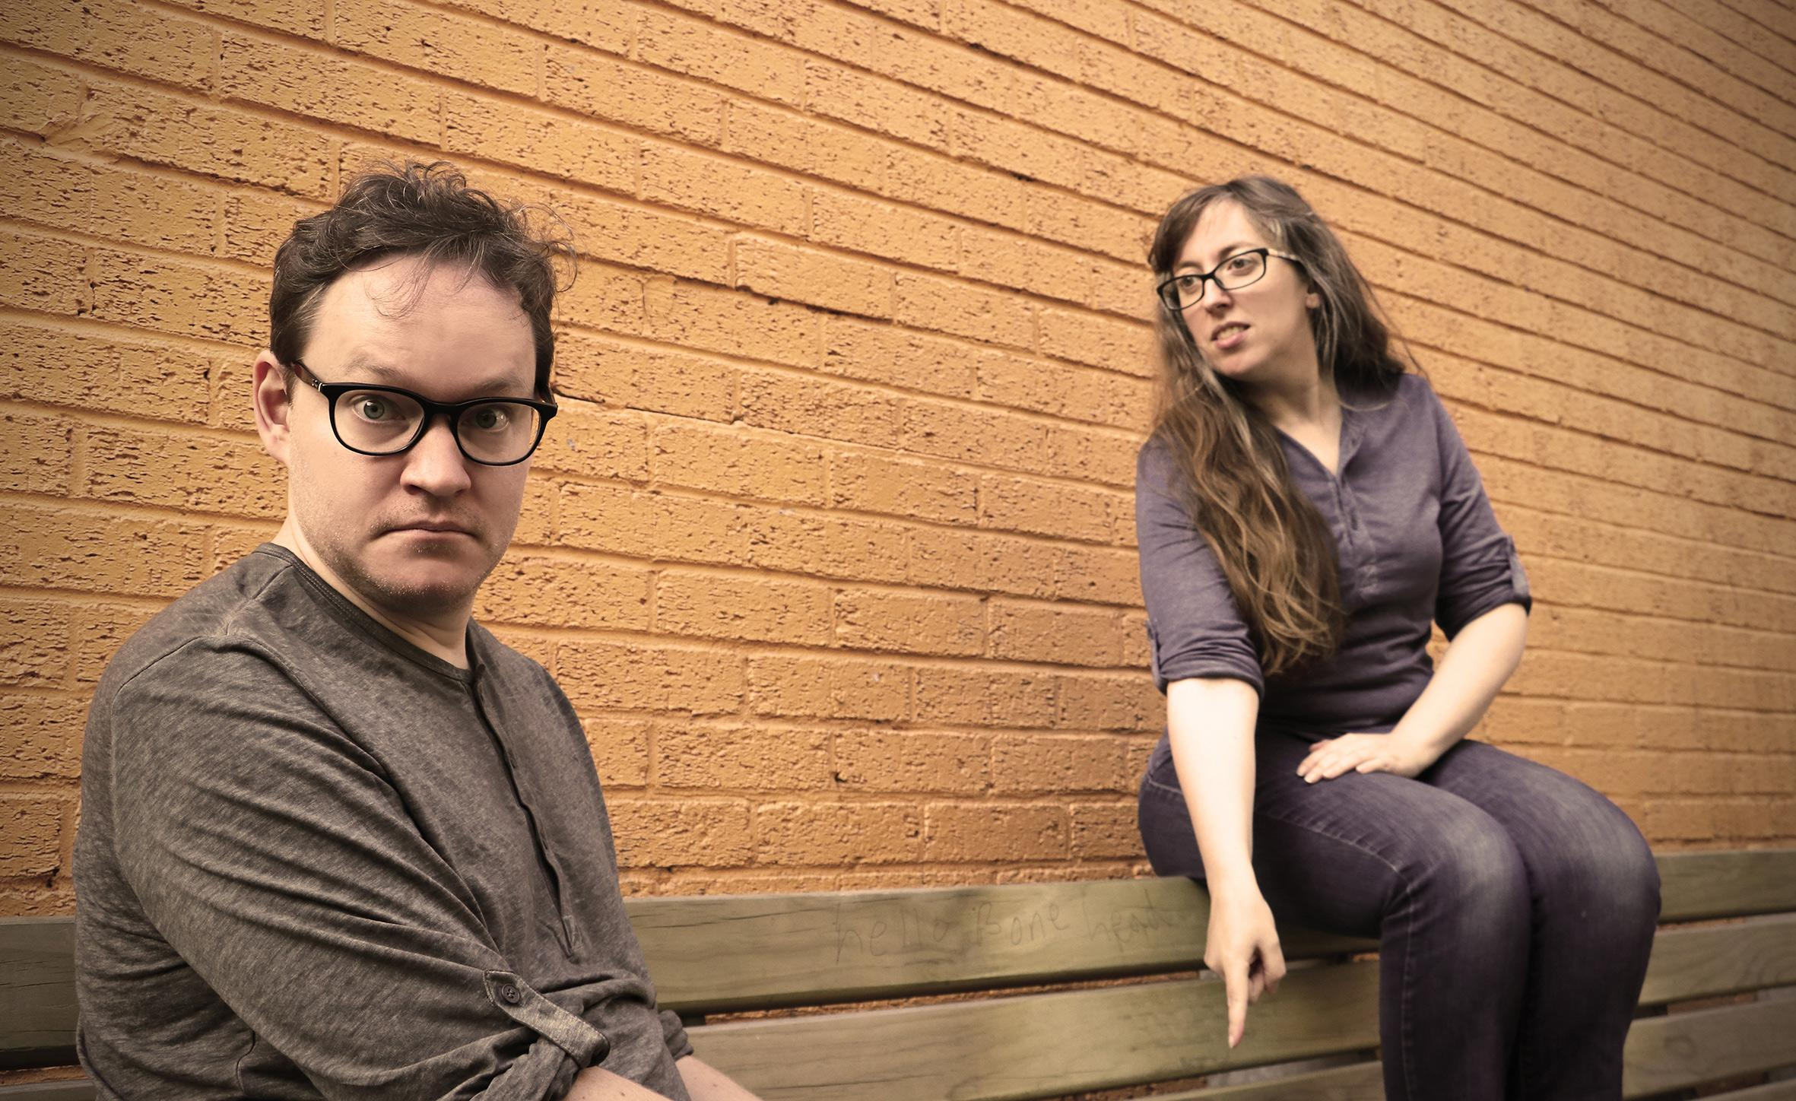
“Our hook is that we have no hook” says Lizzy Mace of international improv duo Awkwardly Quiet. “This show is literally anything” agrees Andreas Södermark. In their debut show Two Idiots, No Script, the pair generate deeply unpredictable and hugely watchable scenes inspired by nothing but the mood of each moment. No pre-set characters, no pre-defined genre, no pre-rehearsed format, just delightful, improvised, clownesque theatre.

Do you want to see:
- a show containing a 20-minute scene about post-apocalyptic betrayal?
- a whole show where every character turns out to be an alien in disguise?
- a 10-minute scene where the only word used is “chair”?
- a show containing the talking skull of a deceased celebrity, pretending to be the talking skull of another deceased celebrity?
- a show that contains no scenes at all, just two idiots trying to decide how to start the show?

All of these things happened in their show once. So they probably won't happen again.

Emerging from the players’ shared love of calm, simple, organic improv, Awkwardly Quiet is equal parts emotional connection and big dumb fun. The performers revel in playing silence and exploring the potential in every moment, creating a show that varies from conversational to silent space play, and from the dramatic to the absurd.

“The only thing we guarantee is that you don't know what you're going to see, because we don't know either,” says Lizzy. “It's the only show on the Fringe where the performers and audience get to discover the entire show together.”

About the company
Awkwardly Quiet is Lecoq-trained actor Andreas Södermark (SWE) and award-winning comedy performer Lizzy Mace (UK). Already experienced performers, they met in Chicago at The Second City in 2013, and are now teaching and performing together internationally.
Andreas trained in the Lecoq tradition – physical theatre/clowning – at The School For Theatre Creators in USA and Italy. Lizzy trained in acting at Mountview Academy of Theatre Arts in London. Last time she performed in Adelaide in 2014, her show Rom Com Con (with Mace and Burton) was picked by SA Life Magazine as one of their top nine shows at the Fringe and received a four-star review from The Australia Times.
“Two Idiots, No Script” at the Adelaide Fringe 2018
6pm (50 minutes) | 4-16 March (not 10 or 15 March) | $12-20
The National Wine Centre, Hackney Rd & Botanic Rd, Adelaide, 5000
Vines Room - 4 March (preview) | Gallery Room - 5-9, 11-14 & 16 March
Tickets can be purchased at FringeTIX: https://adelaidefringe.com.au/fringetix/two-idiots-no-script-af2018
-ENDS-
Links:
Awkwardly Quiet on Facebook: www.facebook.com/AwkwardlyQuiet
Awkwardly Quiet on Twitter: www.twitter.com/PigeonsAndJam
Images:
High resolution images are available to download from Adelaide Fringe or from our press contact (see below)
Press Contact:
For more information, images or to arrange interviews, please contact:
Lizzy Mace | awkwardlyquiet@gmail.com | +44 7712 587044

